Chapter 12 Matter: Properties and Changes Lesson 2 – Matter and Its Changes
Changes of Matter
Physical and Chemical Changes

What are physical changes?
- Physical change – a change in the shape, size, form, or state of matter that does not change the matter’s identity.

Dissolving:
Dissolving – the ability for a material to dissolve, or mix evenly in another. Dissolving is a physical change because the identities of the substances do not change.
Example: Sugar dissolving in water.
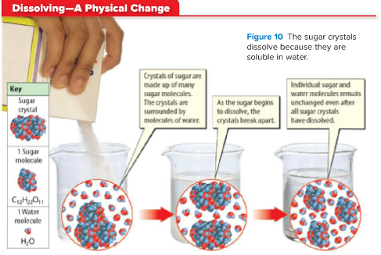

Changing State:
Changes in state or physical changes.
Melting and Boiling:
When a material melts it changes from a solid to a liquid. When it boils it changes from a liquid to a gas.
The substances that make up the material do not change during a phase change.

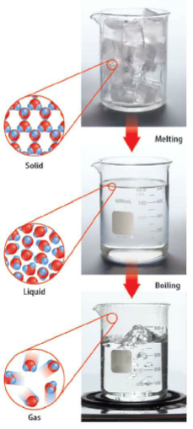

Energy and Change of State:
- The energy of the particles and the distance between particles are different in a solid, a liquid, and a gas.
- Energy must be added to a substance to change it from a solid to a liquid.
- Adding energy to a substance can increase the temperature, when the temperature reaches the substance’s melting point the solid will change to a liquid.
If you change the rate at which you add energy, the substance can reach its melting point more slowly or more quickly.
Example: If you melted an ice cube in your hand it would reach its melting point more slowly than if you heated it in a pot on a stove.

What are Chemical Changes?
Chemical change – is a change in matter in which the substances that make up the matter change into other substances with different chemical and physical properties.

Signs of a Chemical Change:
The only sure sign that a chemical change has occurred is the formation of a new substance. The below signs are “clues” we can use to help us determine if a chemical change may have occurred.
Formation of a Gas:
Bubbles of gas can form during both physical changes (boiling) and chemical changes (Alka-Seltzer). Sometimes you may not see the gas but smell it. For example, when you bake bread, the aroma is a sign that baking bread causes a chemical reaction that produces a gas.

Formation of a Precipitate:
A precipitate is a solid that sometimes forms when two liquids combine.
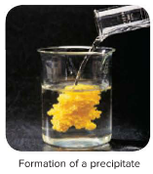
Color Change:
- Color change can be the sign of a physical change (painting the walls) or a chemical change (toasted marshmallows).
- In toasted marshmallows the color changes from white to brown when toasted- representing a chemical change.
- Notice on the previous page the color change in the precipitate photo – this is also a “clue” a chemical change has occurred.
Energy and Chemical Change
- The release of thermal energy, light, and sound are signs a chemical change may have occurred.

Ex: Thermal energy is needed for a chemical reaction to bake pretzels. If you had two pans of unbaked pretzel dough and placed only one pan in the oven, the dough in the hot oven would become pretzels.

- Energy in the form of light (electromagnetic energy) is needed for some chemical reactions.
Example: Photosynthesis is a chemical reaction by which plants produce sugar and oxygen.

Conservation of Mass
Physical and Chemical changes do not affect the mass of substances.
Ex: When ice melts (physical change) the mass of the ice = the mass of the liquid water.

Mass is also conserved in a chemical change.
Ex: The mass of an unburned match plus the mass of the oxygen it reacts with = the mass of the ashes plus the mass of the gases given off when the match burns.
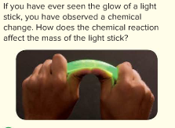
This is called the law of conservation of mass – states the total mass before a chemical reaction is the same as the total mass after the chemical reaction. Antoine Lavoisier made this discovery.

Comparing Physical and Chemical Changes
- The identity of matter does not change during a physical change. The identity of matter does change during a chemical change.
- Sometimes deciding if a physical or chemical change has occurred may require some detective work. You have to look for clues that will help you figure out if the identity of the substance has changed or not.
